For more information, please contact:
Jordan Mellican
IZSAM Clean
402-637-1970
jordanm@izsam.com
http://izsam.com

News Release
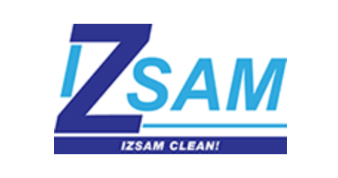

FOR IMMEDIATE RELEASE

HEA INC. CLEANS UP AS FIRST FRANCHISEE OF IZSAM CLEAN!

As family-owned and father-son, co-founded Super Clean Job Site, an IZSAM cleaning company, reaches 18 years, the duo votes in HEA Inc. to take over the local business

OMAHA, Neb., Aug. 29, 2016 – Some say cleanliness is next to impossible, but the owners of HEA, Inc. know that with the right people, equipment and partnerships cleanliness is not only possible it is now their business. As of today HEA is the first official franchisee of IZSAM and it will take over local operations.

“The HEA team is ready to build on the strong foundation and business model set forth by the IZSAM organization and employees,” said Renee Mellican, chief executive officer, HEA, Inc. “We look forward to expanding on the unique niche the Bennett family has established in the cleaning service industry.”

Dan Bennett and his son, Dan Bennett Jr., cofounded the Omaha-based Super Clean Job Site, LLC. in 1998, and capitalized on a combined 50-year industry experience to grow the business encompassing construction clean up and industrial janitorial services. Over time, the two also expanded its services past Omaha to cities like Dallas, Kansas City, Denver and more. Now they are growing by creating IZSAM franchises.

“As entrepreneurs, it has been our dream to continuously grow the business, and we are confident that HEA, Inc. will not only maintain the high quality standards, but also enhance operations,” explained Dan Bennett, Jr., Owner/SCJS Franchising Inc.

Jordan Mellican, president at HEA, will run the day-to-day operations of IZSAM business in the regional area. Jordan has 25 years of extensive business experience at four Fortune 500 companies, including Procter & Gamble, Abbott Labs, ConAgra Foods and Kellogg. He specializes in continuous improvement processes, driving efficiency and effectiveness that resulted in millions of dollars in cost savings, enhanced operations, and new products. He is both a certified Project Management Professional (PMP) and a six sigma black belt. By trade Jordan is a licensed engineer with a degree in Chemical Engineering, and a master’s in business administration.

About IZSAM
IZSAM is a certified and insured professional cleaning company that provides reliable, quality and affordable construction clean up and related cleaning services for every construction site, business and institution it serves. In business since 1998, the company has grown to service more than 400 clients that represent construction sites, schools, hospitals, apartments, hotels, office complexes and more. In 2016, IZSAM launched its first franchise. With passion for a sustainable environment and healthy living, IZSAM is committed to clean green and reduce waste. The company uses ingredients that are planet and people safe, for both clients and employees. For more information, please visit www.IZSAM.com.

# # #

